HOW TO USE MORINGA OLEIFERA POWDER (A.K.A MORINGA LEAF POWDER)
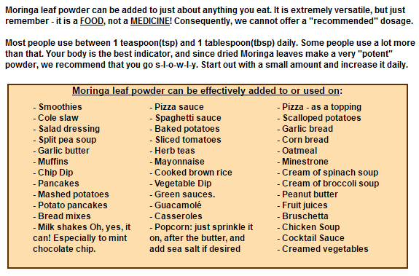

HOW TO USE MORINGA OLEIFERA POWDER (A.K.A MORINGA LEAF POWDER)

